**Java Messing Service (JMS)**

**Messaging** is a method of communication between software components or applications.

The Java Message Service is a Java API that allows applications to create, send, receive, and read messages.

**JMS API Architecture**

A JMS provider

JMS clients

Messages

Administered objects

**Point-to-Point Messaging**

A point-to-point (PTP) product or application is built on the concept of message **queues**, senders, and receivers.

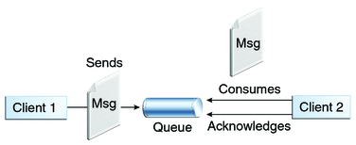

**Publish/Subscribe Messaging**

In a publish/subscribe (pub/sub) product or application, clients address messages to a **topic**.

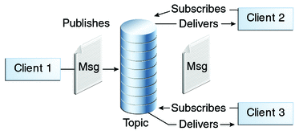

**Message Consumption**

Messaging products are inherently asynchronous:

Messages can be consumed in either of two ways:

Synchronously

Asynchronously

The basic building blocks of a JMS application are:

Administered objects: connection factories and destinations

Connections

Sessions

Message producers

Message consumers

Messages